Report Disclaimer
Please note that this Club Health Check report, provided as a result of the use of the online assessment, is for information purposes only. It is intended to provide an indication of the capability of your club, on the date of the assessment. The scores achieved are based on the answers provided during the assessment.
The Australian Sports Commission (ASC) cannot guarantee the accuracy of respondent’s answers, or that they are fully representative of your club. Therefore, the ASC does not warrant or guarantee any particular outcome in respect of your club’s self-assessment, the Club Health Check report or scoring.
This report, and any information contained within, has been prepared based on the information provided in your club’s self-assessment. It is intended as guidance only for your club and should not be relied on for any legal or financial considerations, or by any third party. Links to external web sites are inserted for convenience and do not constitute endorsement of material at those sites, or any associated organisation, product or service. This information does not constitute professional legal or financial advice, and the ASC recommends that you seek your own independent advice.
The ASC does not:
a) Assume any legal liability for the accuracy, completeness, or usefulness of any information from this report or any links provided; or
b) Accept responsibility for any loss associated directly or indirectly from the use of this report

Dear Maree Dunn (president)

Thank you for taking the time to complete the online Club Health Checklist and investing in your clubs future growth and development.
As you progressed through the Club Health Check, you would have answered questions that explored identified key drivers and critical success factors that are crucial to success at club level. These factors are used to build a picture of the way your club carries out its operations and activities and form the basis to your overall report.
This report is broken down into three sections;
- Action Plan – The six highest priority areas as identified from the answers provided in the checklist are identified in the action plan section along with resources to assist improving these areas.
- Summary report – This gives the scoring for your club against the key drivers and the critical success factors as well as a graphical view of these scores. This section will provide you with a synopsis of all of your results and provide general information on each key area and related resources to assist with improvement.
- Summary of priority responses – This provides a copy of all the questions answered, along with your responses and subsequent priority level. This can give further background to committee discussions and future actions.
The action plan is the key section for your committee to address first, and the action plan templates have been specifically designed to facilitate discussion and guide planning for your club. Details of how to complete these action plans, has been included further in this report.
In a committee that is dedicated to developing and improving its systems and processes as well as proactively looking to the future this report should also form part of the on-going discussions of the committee.
We also strongly recommend you complete this checklist on an annual basis to review how your club is performing and as an on-going continuous improvement process.
We wish you all the best in working through this report and working towards improving your clubs growth, development and sustainability.

National Organisational Development Network

The Club Action Plan
  - Summary Report
  - For
CLUB NAME: Clarence Coast Dragon Boat Club Inc
CONTACT NAME: Maree Dunn (president)
POSTAL CODE: 2464
EMAIL ADDRESS: clarencecoastdbclub@gmail.com
CLUB WORKFORCE: Volunteer administrators
CLUB STATUS: Incorporated: with one organising committee
CLUB LOCATION: Rural
CLUB SPORT: Dragon Boat
CLUB STATE: NSW
ASSESSMENT DATE: Thursday, 2 May 2019

The Action Plan

As a guide, below are the key areas of the action plan template along with steps to follow when completing these templates.

Points to Consider
This text refers directly to the question identified as a priority for the club to address. These points highlight what the question is referring to and what the club needs to think about when developing the action plan.

Best Practice
This section outlines best practice suggestions for the club to consider while developing actions. These statements are designed to give detail to assist in developing the plan and will give a broad overview of aspects that impact on the priority identified. If the club decides not to follow the best practice suggestions, it should as a minimum have a clear understanding of ‘why not’.

Strengths and Opportunities

As a group, fill out all the strengths and opportunities that your club has in each identified priority area. This will then assist you completing the actions to improve section.

Actions to Improve
The committee (or working group if required) should identify clear actions that the committee or club members need to do in order to have an impact on the identified priority area. Based on the complexity of the priority, the committee could list 1-4 different actions. These actions should be measurable and easily conveyed to those responsible for completing.

Responsibility
The committee needs to allocate a responsible person or group to manage the action plan; this could be different people for each action or the same across all action plan items. Whatever the decision the people identified should have the correct skills and knowledge to be able to carry out the task and report to the committee on the outcomes.

Time Frame
The Action Plan is designed to be a short to medium term task that fits within wider planning. The timeframe set by the committee will give the people identified to work on the plan a goal for completion.

How to Measure Outcomes
Each action identified should have a measurable outcome. Below is a quick guide to good planning
Specific | Write actions simply and describe exactly what will be accomplished when each action is achieved.
Measurable | The action needs to be measurable so it can be determined when it has been achieved. If it cannot be measured, it might not be manageable.
Achievable | Expect to achieve the action and do not set actions too high or make them unrealistic.
Related to the priority | The actions must relate to the priority for your club.
Time bound | Each action must have an achieve-by date. A deadline is a great motivator for achieving.

Critical Success Factors

The radar graph below gives a graphical view of your score across the Critical Success Factors from the assessment. The action plan items that have been identified for your club come out of these Critical Success Factors.

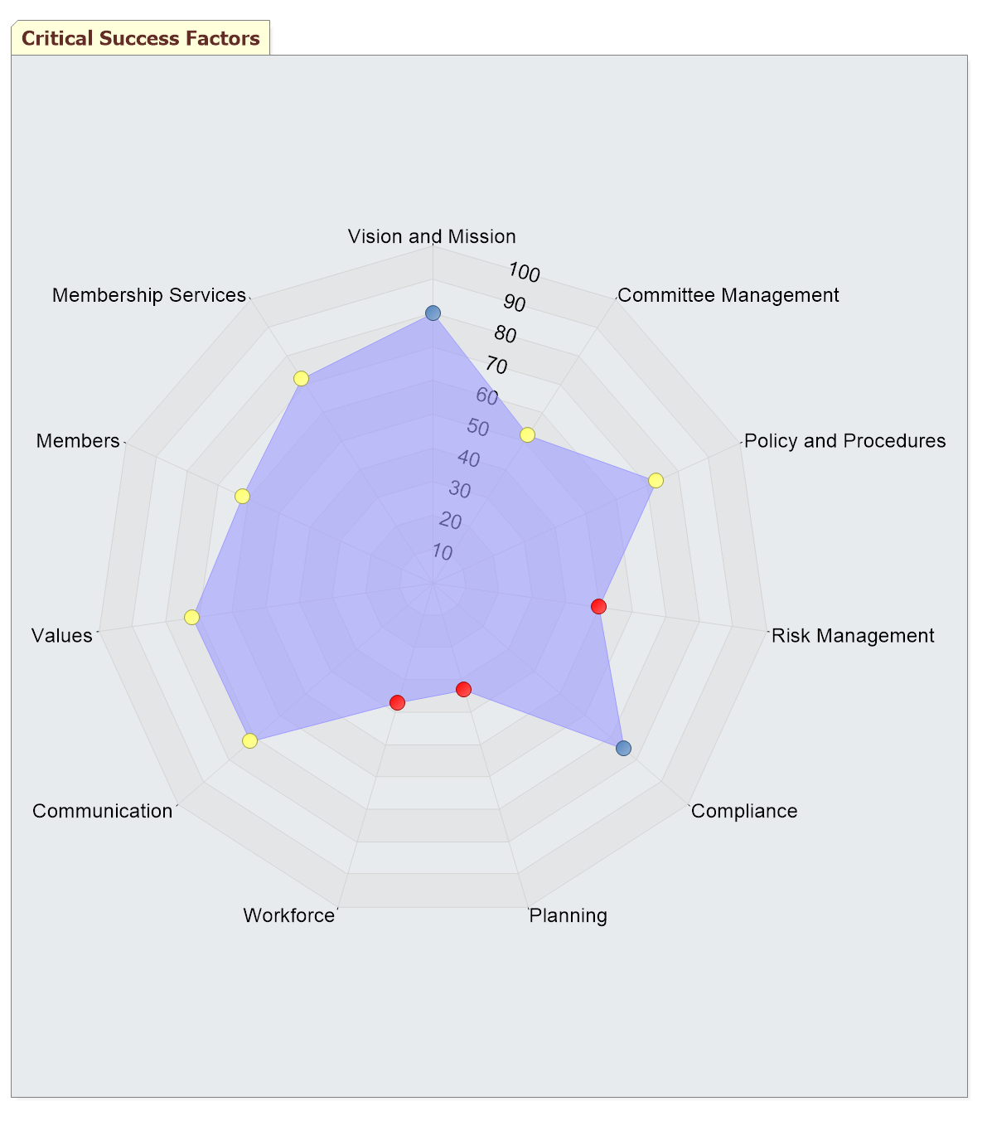 | Legend  High Priority  Medium Priority  Low Priority  On-going
Fig 1. Critical Success Factors Summary Performance (Radar Chart)

Action Plan Item 1
Critical Success Factors: | Risk Management |  | Key Driver: |  | Governance
Question: | 2.3.3 How would you rate you club's current financial health?
Your Response: | Coping |  | Priority Rating:
Points to Consider:
While the club might be a not-for-profit organisation, it is as equally a not-for-loss organisation and many clubs continue to under-charge for what services they provide and struggle in doing so.
Best Practice:
While the club might be a not-for-profit organisation, it is as equally a not-for-loss organisation, and the only sustainable way to accumulate and maintain sufficient reserves is for the club to avoid operating at a loss.
To avoid this, the club’s committee should ensure adequate controls and reporting systems are in place to understand and monitor the club’s operations, risks and finances.
To compliment operations the committee should also have a good understanding and management of the club’s value proposition (how much members are prepared to pay for services), membership pricing structures and other sources of revenue, including minimising any dependencies on particular sources.
In identifying what financial reserves (or savings) are able to be used in unforeseen circumstances, the club should distinguish between general and specific reserves, whereby the club may have covenants over portions of its reserves, e.g. reserves which might be identified for specific purposes and need to be segregated from the general reserves.
In addition to identifying available reserves, the committee should also ensure adequate policies are in place as to the application of general reserves, e.g. if reserves are used, then it should be to ensure the future of the club.
Good practice in the management of reserves should also include policies around how any free reserves are invested back into the club for development.
Our strengths in this area: |  |  |  | Our opportunities in this area:
Club Enters |  |  |  | Club Enters
Actions to Improve |  | Resp. |  | Time Frame |  | Outcomes
Club Enters
Club Enters
Resources to Assist Planning
https://www.sportaus.gov.au/governance/sports_governance_principles#principle_4_board_reporting_and_performance

Action Plan Item 2
Critical Success Factors: | Planning |  | Key Driver: |  | Governance
Question: | 2.5.4 The club committee regularly reviews the club's performance against a plan.
Your Response: | Disagree |  | Priority Rating:
Points to Consider:
The role of the clubs planning documents does not stop with their adoption at the annual general meeting. It is the clubs most important reference document, which should be used constantly throughout the year as a context for decision-making, and for monitoring the performance of the club in terms of its performance and financial situation.
Once the plan is finalised, it is important that it is regularly reviewed.
Tips for monitoring, evaluating and reviewing the plan;
*Identify the people in the organisation who will be responsible for monitoring.
*Ensure specific timeframes have been allocated for the implementation of strategies.
*Develop formal reporting procedures for the identified person to comply with - reporting procedures can be allocated to an action plan group or person, or they can be built into established reporting processes.
*Check progress regularly in relation to what is set out in the plan. This should be included as a regular item on management meeting agendas.
*Modify the plan if it is not possible to achieve some of the goals that have been set.
*Establish a planning subcommittee to review the whole plan each year to check whether the organisation achieved goals for the year and to add another year to the plan. The organisation should be constantly planning three to four years ahead.
Best Practice:
Planning is beneficial to sporting clubs in many ways. The main aim of planning is to maintain a positive relationship between the club and its environment. Specifically, planning enables a club to:
* become proactive rather than reactive — to clarify club purposes and direction
* initiate and influence outcomes in favour of the club
* exert more control over its destiny — deciding where it wants to be in the future
* adopt a more systematic approach to change and reduce resistance to change
* improve financial performance and use resources effectively
* increase awareness of its operating environment (for example, competitors, government policy, threats)
* improve organisational control and coordination of activities
* develop teamwork off the field.
Without adequate planning, the club frequently deals only with immediate problems and fails to consider future needs. Consequently, the club:
* tends to function on a random ad hoc basis
* will never seem to have time to anticipate tomorrow’s problems
* does not create conditions to deal effectively with the future.
Therefore, to overcome these limitations, a plan is necessary.
Our strengths in this area: |  |  |  | Our opportunities in this area:
Club Enters |  |  |  | Club Enters
Actions to Improve |  | Resp. |  | Time Frame |  | Outcomes
Club Enters
Club Enters
Resources to Assist Planning
https://www.sportaus.gov.au/club_development/culture_and_leadership

Action Plan Item 3
Critical Success Factors: | Workforce |  | Key Driver: |  | Governance
Question: | 2.6.2 The club has strategies that target people with specific skills for volunteer positions
Your Response: | Disagree |  | Priority Rating:
Points to Consider:
Providing a supportive environment for volunteers requires consideration of your club’s approach to the recruitment, retention, recognition and support of volunteers.
Whether appointing volunteers, it is important to set up a transparent appointment process to ensure a fair and equitable approach to your recruitment that doesn’t result in disgruntled people. Processes should consider using a skills matrix, requesting and assessing nominations against agreed criteria and formally communicating decisions with applicants.
Your committee should actively plan to make sure that suitable people are available to take up positions as people step down and minimise the risk of lost information (e.g. role descriptions, handover checklist).
It is important that staff and volunteers are provided with the necessary training on the commencement of their role and ongoing support to ensure they are able to do their job. Some clubs will appoint a person (e.g. Chairperson or Volunteer Manager) who is accountable for managing volunteers to ensure they have a direct point of contact responsible for this.
Recognise the importance of your club volunteers and assist and support them to continue in their roles. This may include supporting their professional development, offering volunteering incentives, rewarding your volunteers or offering role rotation.
Best Practice:
Successful clubs have good people doing great things. The people in your club, paid or volunteer, are your workforce and they are the people you need for your club to function e.g. coaches, officials, volunteers, administrators.
If you understand your workforce, the number of people and skills required for the various roles, you are better placed to achieve your clubs desired outcomes.
Workforce planning is about ensuring you have;
* the right people
* in the right roles
* for the right time
* with the right skills, and
* at the right cost.
In addition to these factors you should seek out people who reflect the behaviours and attitudes of the club.
As with any planning process you should apply these best practice principles to your workforce plan;
* the current situation (current workforce breakdown)
* what will you need in the future (workforce breakdown to achieve desired outcomes)
* identify the gaps (what you need to add to achieve desired outcomes)
Our strengths in this area: |  |  |  | Our opportunities in this area:
Club Enters |  |  |  | Club Enters
Actions to Improve |  | Resp. |  | Time Frame |  | Outcomes
Club Enters
Club Enters
Resources to Assist Planning
https://www.sportaus.gov.au/club_development/governance#workforce

Action Plan Item 4
Critical Success Factors: | Committee Management |  | Key Driver: |  | Governance
Question: | 2.1.2 Does your club regularly review the constitution?
Your Response: | No |  | Priority Rating:
Points to Consider:
As a registered association, your club should review the constitution at least every 2 years to ensure it's up to date and usable for the club. Areas to consider in a review include changes to legislation, membership structures, size of the association and your registered status or other activities that impact on the constitution.
The constitution should be written in a clear, unambiguous and succinct manner. It should not be overburdened with items that would be better served to be detailed in the organisation’s by-laws or policies. Usually these items can be expected to be changed and updated from time to time. In these circumstances the committee should, through by-law and policy development, be empowered to oversee and manage the issues.
Most importantly are club operations unimpeded by the constitution?
Best Practice:
To operate most effectively, the board should:
Understand its roles and responsibilities, as individuals, Board Members and as a Board.
* Attract quality people, and have a plan for how it will do this.
* Retain quality people by providing development opportunities.
* Meet regularly enough to perform its roles and responsibilities.
* Operate under a regularly reviewed constitution that is up-to-date and does not impede the organisation from operating effectively and the Board from fulfilling its roles and responsibilities.
* Ensure that only the most important matters and powers are contained in the constitution, with the remainder to be set out in regularly reviewed policies and by-laws.
Our strengths in this area: |  |  |  | Our opportunities in this area:
Club Enters |  |  |  | Club Enters
Actions to Improve |  | Resp. |  | Time Frame |  | Outcomes
Club Enters
Club Enters
Resources to Assist Planning
https://www.sportaus.gov.au/club_development/governance#planning

Action Plan Item 5
Critical Success Factors: | Committee Management |  | Key Driver: |  | Governance
Question: | 2.1.5 The club has a strategy to attract people on to the committee
Your Response: | Disagree |  | Priority Rating:
Points to Consider:
These strategies could include mentoring, succession planning, position descriptions and other communication strategies.
For the committee to operate effectively it should attract the best people possible to identified positions on the committee that compliment other members skills
Best Practice:
To operate most effectively, the board should:
Understand its roles and responsibilities, as individuals, Board Members and as a Board.
* Attract quality people, and have a plan for how it will do this.
* Retain quality people by providing development opportunities.
* Meet regularly enough to perform its roles and responsibilities.
* Operate under a regularly reviewed constitution that is up-to-date and does not impede the organisation from operating effectively and the Board from fulfilling its roles and responsibilities.
* Ensure that only the most important matters and powers are contained in the constitution, with the remainder to be set out in regularly reviewed policies and by-laws.
Our strengths in this area: |  |  |  | Our opportunities in this area:
Club Enters |  |  |  | Club Enters
Actions to Improve |  | Resp. |  | Time Frame |  | Outcomes
Club Enters
Club Enters
Resources to Assist Planning

Action Plan Item 6
Critical Success Factors: | Committee Management |  | Key Driver: |  | Governance
Question: | 2.1.7 How often does your club provide professional development opportunities in governance?
Your Response: | Never |  | Priority Rating:
Points to Consider:
Such as individual training in governance, facilitated group development sessions for the committee or specific training targeted to develop the skills of the committee to assist it in making decisions
Best Practice:
To operate most effectively, the board should:
Understand its roles and responsibilities, as individuals, Board Members and as a Board.
* Attract quality people, and have a plan for how it will do this.
* Retain quality people by providing development opportunities.
* Meet regularly enough to perform its roles and responsibilities.
* Operate under a regularly reviewed constitution that is up-to-date and does not impede the organisation from operating effectively and the Board from fulfilling its roles and responsibilities.
* Ensure that only the most important matters and powers are contained in the constitution, with the remainder to be set out in regularly reviewed policies and by-laws.
Our strengths in this area: |  |  |  | Our opportunities in this area:
Club Enters |  |  |  | Club Enters
Actions to Improve |  | Resp. |  | Time Frame |  | Outcomes
Club Enters
Club Enters
Resources to Assist Planning

The Club Health Check – Summary report

Best Practice Model – Club Rating
In addition to the summary reports and action plan, this report takes the responses and calculates a balanced score which will place your club within a rating made up of four levels. Each of these levels has a basic and generic description that lays out the progression of any sporting organisations from a novice club to a mature club that is operating at its peak capacity. These levels do not correspond to size or wealth but directly to the level at which the committee is developing the club.
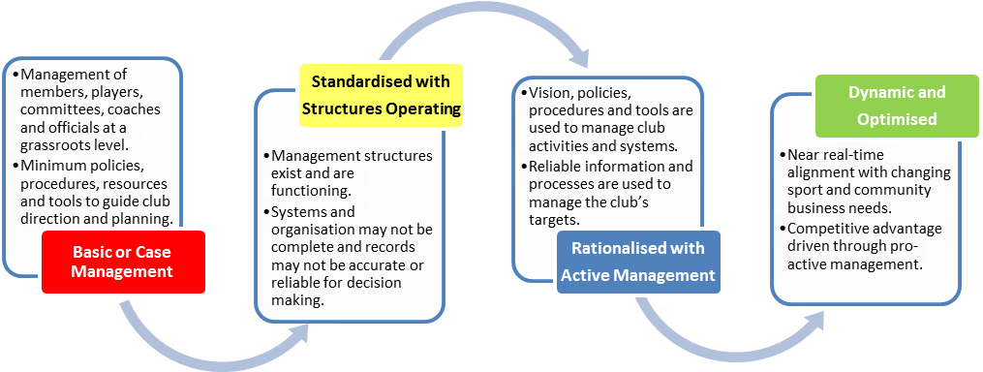

The purpose of the Club Rating is to provide an incentive for progression. The action plan in this report will provide guidance for improving your overall performance and subsequent rating each time you return to conduct the Health Check.

Your overall Club rating
Standardised with Structures Operating
* Management structures exist and are functioning.
* Systems and organisation may not be complete and records may not be accurate or reliable for decision making.

Key Drivers Summary Performance
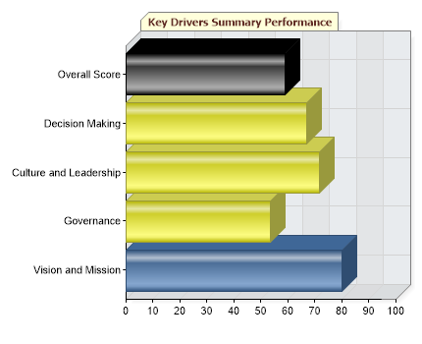 | Legend  High Priority  Medium Priority  Low Priority  On-going
Fig 2. Key Drivers Summary Performance

Feedback on Key Driver Priorities
High Priority
Medium Priority
Governance
Governance is the system by which organisations are directed and managed. It influences how the objectives of the organisation are set and achieved, spells out the rules and procedures for making organisational decisions and determines the means of optimising and monitoring performance, including how risk is monitored and assessed.
The ASC recognises that effective sports governance requires leadership, integrity and good judgment. Additionally, effective governance will ensure more effective decision making, with the organisation demonstrating transparency, accountability and responsibility in the activities undertaken and resources expended.
It is commonly accepted that governance structures have a significant impact on the performance of sporting organisations. Poor governance has a variety of causes, including committee member inexperience, conflicts of interest, failure to manage risk, inadequate or inappropriate financial controls, and generally poor internal systems and reporting.
Governance concerns three key issues:
* how an organisation develops strategic goals and direction
* how the board of an organisation monitors the performance of the organisation to ensure it achieves these strategic goals, has effective systems in place and complies with its legal and regulatory obligations
* ensuring that the board acts in the best interests of the members.
Culture and Leadership
Culture in the context of your club refers to the character of its operating ‘climate’ and collective ‘personality’. This is shaped by its core values, beliefs, principles, traditions, ingrained behaviours, communication, practices, and style of operation. The culture is driven by the leaders of the club who set the core values and then the standards and behaviours or what is acceptable and what is not, this defines for the club ‘how we do things’.
Decision Making
For a club to understand the value of its products and services and to inform decision making across the organisation there must be clear evidence that underpins this process. This information can then be used in the development, delivery, improvement and promotion of the club.

Low Priority
Vision and Mission
A vision statement should illustrate what the sporting organisation wants to become in the future. For example, a vision statement may be ‘Our vision is to be recognised as a world leader’. A vision statement is the first step in the strategic planning process followed closely by the development of a mission statement.
A mission statement is a brief description of a sporting organisation’s purpose and identifies the scope of what the organisation does. For example, a mission statement may be ‘Our mission is to develop and deliver effective services and support to our stakeholders’. It is important that whatever vision and mission is developed, it reflects the aspirations of the stakeholders.

On-going Priority

Critical Success Factors Summary Performance
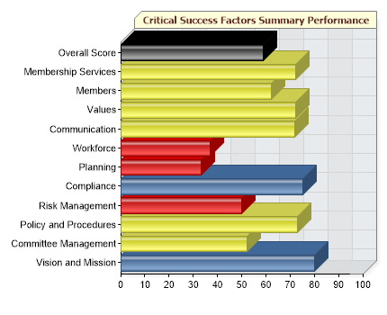 | Legend  High Priority  Medium Priority  Low Priority  On-going
Fig 3. Critical Success Factors Summary Performance (Bar Graph)

Feedback on Critical Success Factor Priorities
Below is a list of areas which have been identified as requiring attention including relevant resources to assist development. Use this information to guide committee discussion and planning to achieve higher scores across these areas and progress through the Club Rating model:
Priority | Best Practice
Vision and Mission
A vision statement should illustrate what the sporting organisation wants to become in the future. For example, a vision statement may be ‘Our vision is to be recognised as a world leader’. A vision statement is the first step in the strategic planning process followed closely by the development of a mission statement.
A mission statement is a brief description of a sporting organisation’s purpose and identifies the scope of what the organisation does. For example, a mission statement may be ‘Our mission is to develop and deliver effective services and support to our stakeholders’. It is important that whatever vision and mission is developed, it reflects the aspirations of the stakeholders.
A quick test of a good mission statement is to ask:
Does it describe a purpose for the organisation?
Does it capture the culture of the organisation?
Does it describe the strategic positioning of the organisation?
Is it easy to read?
Is it general enough to adapt to ongoing changes, yet specific enough to impact on the behaviour of the organisation’s people?
Resource(s)
https://www.sportaus.gov.au/club_development/vision_and_mission
Committee Management
To operate most effectively, the board should:
Understand its roles and responsibilities, as individuals, Board Members and as a Board.
* Attract quality people, and have a plan for how it will do this.
* Retain quality people by providing development opportunities.
* Meet regularly enough to perform its roles and responsibilities.
* Operate under a regularly reviewed constitution that is up-to-date and does not impede the organisation from operating effectively and the Board from fulfilling its roles and responsibilities.
* Ensure that only the most important matters and powers are contained in the constitution, with the remainder to be set out in regularly reviewed policies and by-laws.
Resource(s)
http://www.ausport.gov.au/supporting/clubs/governance/committee_management
Policy and Procedures
Policies and procedures (written and un-written) are used in an organisation to guide decision making and provide transparency. Irrespective of size, all sporting clubs should adopt a series of basic policies and procedures. Most of these can be re-drafted or directly taken from parent body documents at state and/or national level.
Your sport should have a set of these base line documents that all participants can refer to and usually would contain policies such as;
* Member protection
* Codes of Conduct for players, committee, officials, coaches, spectators and volunteers
* Judicial process and Dispute Resolution
The combination of these policies applied to activities at your club will also assist in dealing with certain risk management issues as many policies outline preventative measures to the issues addressed.
Once policies are in place it is important that they are regularly reviewed and updated where needed. If the policy is an adopted one from a parent body then this review will include ensuring that the policy is the most recent one and that the parent body has undertaken the necessary steps of review.
Policies are only as good as the people who use them; the most common mistake made by organisations is not actively referring to their policy to guide decisions. The club should ensure that all committee members and club members are aware of the relevant policies that impact on their participation.
Resource(s)
https://www.sportaus.gov.au/club_development/governance#policy_amp_procedure
Risk Management
While the club might be a not-for-profit organisation, it is as equally a not-for-loss organisation, and the only sustainable way to accumulate and maintain sufficient reserves is for the club to avoid operating at a loss.
To avoid this, the club’s committee should ensure adequate controls and reporting systems are in place to understand and monitor the club’s operations, risks and finances.
To compliment operations the committee should also have a good understanding and management of the club’s value proposition (how much members are prepared to pay for services), membership pricing structures and other sources of revenue, including minimising any dependencies on particular sources.
In identifying what financial reserves (or savings) are able to be used in unforeseen circumstances, the club should distinguish between general and specific reserves, whereby the club may have covenants over portions of its reserves, e.g. reserves which might be identified for specific purposes and need to be segregated from the general reserves.
In addition to identifying available reserves, the committee should also ensure adequate policies are in place as to the application of general reserves, e.g. if reserves are used, then it should be to ensure the future of the club.
Good practice in the management of reserves should also include policies around how any free reserves are invested back into the club for development.
Resource(s)
https://www.sportaus.gov.au/club_development/governance#risk_management
Compliance
As part of the organisation’s risk management process at the committee management level, it should be aware of the environment that it is operating in. The process of determining risk, carried out through various risk assessments should include looking at the clubs:
a. Rules
b. Regulations
c. Legislation
By carrying out this type of risk assessment your club will then have a working understanding of how decisions impact on;
a. Sources of risk;
b. When and where the risk could happen;
c. The effect of the risk on the organisation’s objectives;
d. Who might be impacted?
When analysing the risks identified by the assessment the committee should consider the likelihood and consequences of the risk happening. By doing so they can then evaluate the risks to determine;
a. What is the organisation’s risk tolerance, high or low?
b. Can the risk be dealt with?
c. Is it tolerable or intolerable?
Once these factors have been determined by the committee it should then decide how it will deal with the risks by either;
- Avoiding the risk
- Taking the risk
- Minimising the risk
These actions should also include strategies such as removing the source of the risk or assess the costs and benefits of dealing with the risk.
Risk management is not just confined to committee decisions but should be a part of the clubs normal activities when delivering the sport at all levels. As a result the committee should also be aware of any flow-on effect from decisions when assessing risk i.e. a cut in budget could have a risk outcome for the running of competitions or training.
Resource(s)
https://www.sportaus.gov.au/club_development/governance#compliance
Planning
Planning is beneficial to sporting clubs in many ways. The main aim of planning is to maintain a positive relationship between the club and its environment. Specifically, planning enables a club to:
* become proactive rather than reactive — to clarify club purposes and direction
* initiate and influence outcomes in favour of the club
* exert more control over its destiny — deciding where it wants to be in the future
* adopt a more systematic approach to change and reduce resistance to change
* improve financial performance and use resources effectively
* increase awareness of its operating environment (for example, competitors, government policy, threats)
* improve organisational control and coordination of activities
* develop teamwork off the field.
Without adequate planning, the club frequently deals only with immediate problems and fails to consider future needs. Consequently, the club:
* tends to function on a random ad hoc basis
* will never seem to have time to anticipate tomorrow’s problems
* does not create conditions to deal effectively with the future.
Therefore, to overcome these limitations, a plan is necessary.
Resource(s)
https://www.sportaus.gov.au/club_development/governance#planning
Workforce
Successful clubs have good people doing great things. The people in your club, paid or volunteer, are your workforce and they are the people you need for your club to function e.g. coaches, officials, volunteers, administrators.
If you understand your workforce, the number of people and skills required for the various roles, you are better placed to achieve your clubs desired outcomes.
Workforce planning is about ensuring you have;
* the right people
* in the right roles
* for the right time
* with the right skills, and
* at the right cost.
In addition to these factors you should seek out people who reflect the behaviours and attitudes of the club.
As with any planning process you should apply these best practice principles to your workforce plan;
* the current situation (current workforce breakdown)
* what will you need in the future (workforce breakdown to achieve desired outcomes)
* identify the gaps (what you need to add to achieve desired outcomes)
Resource(s)
https://www.sportaus.gov.au/club_development/governance#workforce
Communication
Effective marketing and communication can attract members, sponsors, volunteers and funders. The more people who know about your club, the more opportunities that might come your club's way. Marketing and communication initiatives are also a good way to promote (and thank) your sponsors, funders and other community partners.
Effective marketing and communication means both doing more with less, but also ensuring your messages are being seen and heard by the appropriate audiences.
Promoting your club can include events, activities and advertising, however proactively sharing stories of successes and highlights can be just as effective. The club should also ensure information is made available for people wanting to get involved as participants, coaches, officials, volunteers or supporters.
There are a number of ways to deliver these messages, including club networks and meetings, noticeboards, newsletters, emails, SMS, media releases, local and community newspapers and radio, school newsletters, website posts, YouTube, Facebook, twitter, other community forums and event calendars etc.
The key is for communication to be regular, in order to retain interaction with your members and stakeholders, but also ensure your community is aware of your club and activities.
The simple task of ensuring the club’s contact details are listed in the phone book and local directories is also important but can often be overlooked.
Another important consideration is for the club to meet the needs of their customers, by understanding WHAT people want to know about, and the WHEN and HOW they want to receive that information. This is particularly important when needing to deliver messages to members about events, competitions, facilities or club announcements.
Resource(s)
https://www.sportaus.gov.au/club_development/culture_and_leadership
Values
Clubs can increase their memberships and their social standing in the community by creating inclusive and safe environments through the following strategies:
* finding out which people in their community needs them – targeting women, juniors, people with disabilities and people of varying cultures and ethnicities;
* developing specific programs which encourage participation;
* utilising their clubrooms and facilities as a place for people to meet socially after games or on specific days; many people meet members of the local community by participating in the social events put on by their sporting club;
* scheduling games/events so the whole family can attend on the same day and then enjoy refreshments together at the end;
* involving more juniors in the club – more juniors means more parents, which results in a vibrant community atmosphere and increases the pool of potential volunteers for the club;
* getting involved with local schools to recruit new junior members;
* welcoming new mums back to the sport by providing informal child care, and scheduling events at family-friendly times, e.g. on Sundays;
Your club should facilitate this behaviour through the application of various policies and procedures including;
* Training in the service of alcohol
* Establishing and promoting Codes of Conduct and conflict resolution policies
* Communicating the clubs values to its members and community
* Ensuring transparency and fairness when dealing with conflict resolution.
Resource(s)
https://www.sportaus.gov.au/club_development/culture_and_leadership
Members
As part of the clubs risk management, communication and marketing and strategic planning the committee should understand the rate at which it is growing. Understanding why people join, continue, or leave the club is vital information when developing the way the club operates. This information also feeds back to medium and long term financial planning, facilities planning and volunteer planning as it impacts on the clubs capacity to service its members.
Aspects that should be considered include;
* how are you promoting your club?
* are you talking to the right audience?
* is the club offering the right services?
what is the competition for the club? i.e. other clubs with similar programs
Resource(s)
https://www.sportaus.gov.au/club_development/governance#workforce
Membership Services
Irrespective of the clubs size it should operate a simple but secure database of its member’s details. This information should be regularly tested to ensure it is secure and that the member’s private information is not at risk.
By collecting member information the club can base decisions on demographics, participation rates and many other criteria dependant on what is being collected. Attaching online, automated payments and updating of member details will increase the value and integrity of this information.
When collecting information from members either online or via methods that are more traditional like registration forms the club should ensure that it is providing enough information to the members for them to understand what the club intends to do with the data and how it is stored.
Resource(s)
https://www.sportaus.gov.au/club_development/membership

Summary of Priority Areas

Following are the question you responded to as ‘Unsure’ or ‘Don't Know’, in addition to the Action Plan we recommend that the committee investigate these to determine the level of implementation.
Question |  | Response
Governance
Compliance
2.4.2b | Does your club have professional indemnity insurance for committee members? | Don't Know

Following is a table of all responses for your club. Outside of the Action Plan any area identified as a high priority should be considered by the committee as it may have an impact on the outcomes in the Action Plan.
Note: Questions highlighted in yellow correspond to your clubs Action Plan. Questions highlighted in bold text have been identified as the most critical questions for a club to score high in.
Question |  | Response | Score
Vision and Mission
Vision and Mission
1.1 | Our club understands why it exists and what it's trying to achieve | Yes
1.2 | Our club is guided by a stated vision | Somewhat
Governance
Committee Management
2.1.1 | Does your club regularly refer to the constitution to guide meetings, structures & processes? | Yes
2.1.2 | Does your club regularly review the constitution? | No
2.1.3 | Are your by-laws, policies and constitution separate? | Yes
2.1.4 | Do you believe the committee meets regularly enough to make decisions that achieve your desired outcomes? | Agree
2.1.5 | The club has a strategy to attract people on to the committee | Disagree
2.1.6 | Committee members understand their roles and responsibilities | Agree
2.1.7 | How often does your club provide professional development opportunities in governance? | Never
Policy and Procedures
2.2.1 | To assist decision making does your club refer to a set of policies? | Very Often
2.2.2 | To what degree is your Member Protection policy aligned with either your state or national sporting organisations policy? | Partially Aligned
2.2.2a | To what degree is your Codes of Conduct aligned with either your state or national sporting organisations policy? | Partially Aligned
2.2.2b | To what degree is your Judicial and Dispute Resolution policy aligned with either your state or national sporting organisations policy? | Fully Aligned
2.2.3 | How often does your club committee review its policies to ensure they are current? | Every 2 Years
Risk Management
2.3.1 | The club compiles an annual budget when developing the plan for the year. | Sometimes
2.3.2 | The club monitors progress against the budgets | Very Often
2.3.2a | The club uses an accounting package to record financial transactions | Very Often
2.3.3 | How would you rate you club's current financial health? | Coping
2.3.4 | Other than membership does your club receive more than 40% of its revenue from a single source? If so, which | Yes
Fundraising, eg Bunnings BBQ, market stall, raffles. We have applied for NSW soprts grants to help buy equipment. If we didn't raise funds like this we would not be able to operate.
2.3.5 | Does your club provide an annual report with a complete set of financial statements to members at an AGM? | Yes
Compliance
2.4.1 | Our Club complies with all rules regulations and legislation | Definitely
2.4.2 | Our club manages and maintains facilities to a high standard | Somewhat
2.4.2a | Does your club have public liability insurance? | Yes
2.4.2b | Does your club have professional indemnity insurance for committee members? | Don't Know
2.4.3 | Does your club have personal injury insurance for athletes? | Yes
2.4.5 | When you provide food and drink is your club fully aware of the compliance regulations in accordance with the appropriate authority? | Definitely
Planning
2.5.1 | How would you describe your club's planning? | Short Term (Annual)
2.5.2 | Key stakeholders are actively consulted and involved in developing the goals we are trying to achieve | Mostly
2.5.3 | The facility you use has the capacity to support your club's growth? | Strongly Disagree
2.5.4 | The club committee regularly reviews the club's performance against a plan. | Disagree
Workforce
2.6.1 | We often have to find new volunteers for key roles in the club | Frequently
2.6.2 | The club has strategies that target people with specific skills for volunteer positions | Disagree
2.6.3 | Does your club appoint a Volunteer Coordinator to manage and allocate volunteers across the club? | Somewhat
2.6.4 | Does your club allocate responsibilities for volunteers in a flexible way that caters to the needs of the volunteer workforce? | Somewhat
2.6.5 | Does your club provide regular feedback on performance to volunteers with the purpose of identifying professional development opportunities? | Occasionally
2.6.6 | How often does your club provide professional development opportunities for coaches and officials? | Occasionally
2.6.7 | How often does your club provide professional development opportunities for people who run the club? | Never
Culture and Leadership
Communication
3.1.1 | Our club provides opportunities for members to give regular feedback | Frequently
3.1.2 | Our club uses a targeted communication plan when promoting itself | Frequently
3.1.3 | Our club is engaged within our sport and the community | Frequently
3.1.4 | Does your club have a website that is integrated with your state and/or national website? | Yes
3.1.5 | How effective is your club at using social media tools to communicate to the community? | Not very
Values
3.2.1 | Our club is actively engaged in strategies to attract diversity in its membership. | Agree
3.2.2 | Our club provides a safe environment for members and the community | Agree
3.2.3 | Our club positively manages behaviour and promotes fair play | Strongly Agree
Decision Making
Members
4.1.1 | What percentage of your members have not re-joined from last season? | 0-10
4.1.2 | What percentage of your members have joined as new members? | 19-10
4.1.3 | Do you collect information from members to understand why they are not rejoining? | Sometimes
Membership Services
4.2.1 | Our club records membership information in a secure format | Agree
4.2.2 | Your club has access to allow membership to manage their own registration and details securely online | Partially
4.2.3 | Club members can pay fees online | Yes

